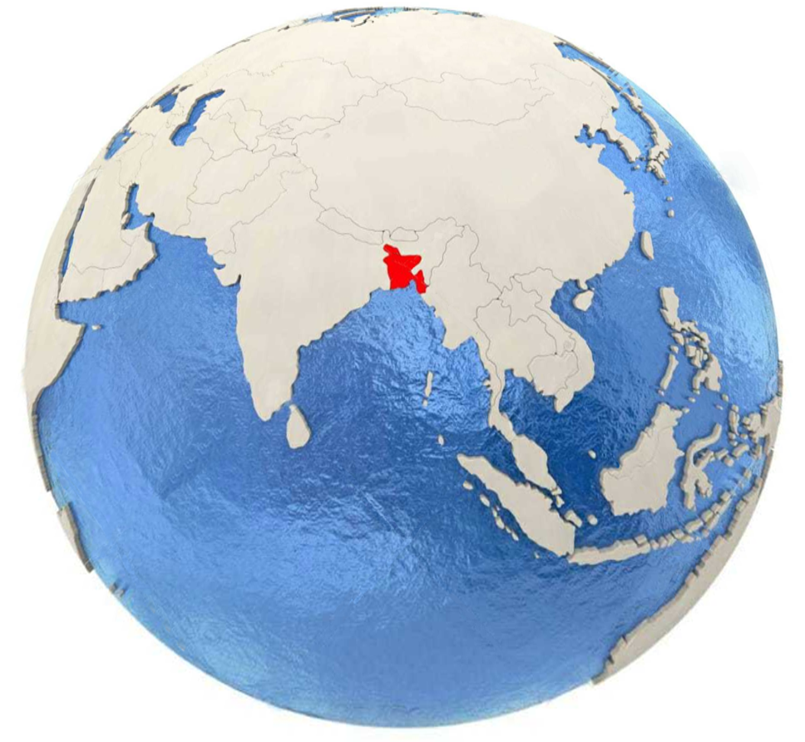

**October 11, 2021**

**BANGLADESH IN GLOBAL PERSPECTIVE**

**Bangladesh in China**

* *Bangladesh urged to build stronger health system for tackling climate-sensitive diseases*

**China.org**

As vulnerable countries are exposed to public health risks from weather pattern consequences of climate change, **Bangladesh** is urged to build a stronger health system in order to cope with an increase in climate-sensitive diseases. The newly released World Bank Climate Afflictions Report said study finds a link between changing climatic conditions and an increase in the cases of respiratory, waterborne, and mosquito-borne diseases in **Bangladesh**.

…

Mercy Tembon, the World Bank country director for **Bangladesh** and Bhutan, said, "**Bangladesh** has remarkably tackled climate change challenges, despite being among the most vulnerable countries. It has built resilience against natural disasters and introduced homegrown solutions to improve agricultural productivity."

…

"Going forward, by ensuring stronger data collection, **Bangladesh** can better track the evolution of climate-sensitive diseases," said Iffat Mahmud, World Bank senior operations officer and co-author of the report.

<http://www.china.org.cn/world/Off_the_Wire/2021-10/10/content_77799872.htm>

**Bangladesh in India**

* *Chamber of commerce for Bangladesh, NE India mooted*

**Deccan Herald**

In a bid to enhance trade between the northeast region of India and **Bangladesh**, business associations from both sides are working on setting up a chamber of commerce. While chambers of commerce for increasing business relations between the two countries are already in existence, the need for a trade body comprising representatives from the northeastern states and the neighbouring country is being pitched, a source said.

…

"My office has always been lending all help and cooperation for improving trade relations between the two countries. We have been supportive of endeavours to bring the two neighbours closer," he told PTI. "The North East region of India is quite far from the national capital, and when talks between India and **Bangladesh** are held on trade issues, problems related to the region are often not addressed,” the source said.

…

He had emphasised on the need to expand the number of trading items with **Bangladesh**, currently confined to extracted natural resources. The trade between the two countries was recorded at $9.5 billion in 2019, of which India’s export to **Bangladesh** was valued at $8.2 billion.

<https://www.deccanherald.com/national/east-and-northeast/chamber-of-commerce-for-bangladesh-ne-india-mooted-1039349.html>

* *Dhaka to construct another nuclear power plant after completion of Rooppur project*

**ANI News**

Prime Minister of **Bangladesh** Sheikh Hasina on Sunday announced the launch of a new nuclear power project upon the completion of the Rooppur Nuclear power plant. The Rooppur Nuclear Power Plant is currently under construction at around 87 miles west of Dhaka, Sputnik Reported citing **Bangladesh** Sangbad Sangstha (BSS) news agency. "We are going to install another (nuclear) power plant after completion of the existing one. We will construct it in the southern region. If we are able to build another nuclear power plant, we will no longer face a power crisis," PM Hasina said. The PM also stressed that **Bangladesh** is becoming a developed nation, noting that she is committed to make **Bangladesh** a fully developed nation by 2041, Sputnik reported.

<https://www.aninews.in/news/world/asia/dhaka-to-construct-another-nuclear-power-plant-after-completion-of-rooppur-project20211010212119/>

**Bangladesh in Malaysia**

* *India may lift ban on export of vaccines under Covax*

**The Star**

WITH the Covid-19 situation in India improving rapidly, there is wide expectation that it would soon resume export of vaccines. “I would not be surprised if we hear something positive very soon,” said Pratyaya Amrit, the Additional Chief Secretary at the Health Department of India’s Bihar state, on the possible lifting of the ban on export of vaccines to Covax countries.

…

Covax is a WHO initiative aimed at securing equitable access to Covid-19 vaccines. Its stocks were seriously depleted after India, the world’s largest producer of vaccines, suspended exports when the pandemic situation aggravated a few months ago. Countries such as **Bangladesh**, Myanmar, Nepal and many African countries are waiting for resumption of vaccine exports from India.

…

“Public health is dependent on the public health system, of being able to vaccinate quickly. It’s an investment against future disease outbreaks to have a resilient, better-prepared system, from development of vaccines, R&D and rural monitoring, that can face the next disease outbreak,” he said.

<https://www.thestar.com.my/news/focus/2021/10/10/india-may-lift-ban-on-export-of-vaccines-under-covax>

**Bangladesh in Pakistan**

* *BD signs UN deal to help Rohingya refugees on Bhasan Char island*

**The International News**

DHAKA: United Nations (UN) officials signed a deal with **Bangladesh** on Saturday to help provide basic services to thousands of Rohingya Muslim refugees who have been moved to camps on a remote island in the Bay of Bengal.

…

The **Bangladeshi** government has moved nearly 19,000 Rohingya refugees to Bhasan Char island from border camps despite protests by some refugees and opposition from rights groups, who say the low-lying island is vulnerable to flooding and storms.

…

Some Rohingya have spoken of being coerced to go to Bhasan Char, but **Bangladesh** says relocation is voluntary and has dismissed safety concerns - citing the building of flood defences, housing for 100,000 people and hospitals.

<https://www.thenews.com.pk/print/899105-bd-signs-un-deal-to-help-rohingya-refugees-on-bhasan-char-island>

**Bangladesh in Saudi Arabia**

* *Dubai: Bangladeshi expat wins Dh1 million at live Mahzooz draw*

**Khaleej Times**

A **Bangladeshi** national has become the latest winner of the Dh1 million Mahzooz live draw that took place in Dubai on Saturday night. The expat was announced as the second prize winner at the 46th weekly draw, after he matched five out of six numbers at the draw, making him Mahzooz’s 16th millionaire this year. Additionally, 102 winners bagged Dh1,000 each, while Dh35 went to 1,984 participants. The total prize money won in last night’s draw was Dh1,171,440. The first prize of the Mahzooz draw is Dh50 million, which is still waiting to be won and will once again be up for grabs this Saturday, October 16, at 9pm UAE time.

Those who missed out on this week’s draw can participate by registering via www.mahzooz.ae and purchasing a bottle of water for Dh35. Each bottle of water purchased provides eligibility for one line in the draw and will be donated and channelled through Mahzooz’s community partners to hydrate those in need.

<https://www.khaleejtimes.com/news/dubai-bangladeshi-expat-wins-dh1-million-at-live-mahzooz-draw>

* *Bahrain removes 11 states from travel red list*

**Arab News**

MANAMA — Bahrain has updated travel measures related to COVID-19 curbs, removing 11 more countries from its red list. The kingdom’s civil aviation authorities said that as of October 10, South Africa, Namibia, Uganda, Mozambique, Zimbabwe, Malawi, **Bangladesh**, Indonesia, Myanmar, Georgia, and Ecuador will be removed from the list. Romania was, meanwhile, added to the red list in the latest update, raising to 16 the total number of countries placed on the list. The Bahraini Civil Aviation Affairs said the update was based on a recommendation made by the country’s National Taskforce for Combatting COVID-19. In August, Bahrain removed India, Pakistan, Panama and the Dominican Republic from the red list. The pre-arrival PCR tests are no longer required for those entering Bahrain from non-Red List countries whose vaccination certificates are recognized. Passengers from red list countries, including those who have transited through those countries in the preceding 14 days, are banned from entering Bahrain. Only Bahraini citizens and foreign residents are exempted from the ban. — Agencies

<https://saudigazette.com.sa/article/611986/World/Bahrain-removes-11-states-from-travel-red-list>

**Bangladesh in Singapore**

* *Rohingya refugees seek escape from promised sanctuary in Bangladesh*

**The Straits Times**

DHAKA (NYTIMES) - Its name translates into "floating island", and for up to 100,000 desperate war refugees, the low-slung landmass is supposed to be home.

…

After years in a refugee camp prone to fires and floods, he accepted an invitation from the government of neighbouring **Bangladesh** to move to the island, Bhasan Char.

…

The promise of an apartment on Bhasan Char held appeal. In January, while other families were forced to go there, he volunteered. They carried a few blankets and two bags of clothes. He came to regret the decision. When he arrived back at Cox's Bazar in August, he saw it with new eyes. "I felt as if I was walking into my home."

<https://www.straitstimes.com/asia/south-asia/rohingya-refugees-seek-escape-from-promised-sanctuary-in-bangladesh>

* *Australia's Wade eyes middle-order role at T20 World Cup*

**CNA**

Australia's Matthew Wade is hopeful that he can seal a middle or lower-order position in the team's batting line-up for the Twenty20 World Cup but believes he can also fill in as opener if required. Wade has not played any cricket since Australia's 4-1 T20 series defeat by **Bangladesh** in August, in which he batted at number five in the first two games before moving to the top of the order.

…

The 33-year-old had a disappointing time in **Bangladesh**, scoring 42 runs in five innings at an average of 8.40, and struggled against the West Indies prior to that, managing 87 runs in five games.

…

Australia kick off their T20 World Cup campaign against South Africa in Abu Dhabi on Oct. 23.

<https://www.channelnewsasia.com/sport/australias-wade-eyes-middle-order-role-t20-world-cup-2234011>

**Bangladesh in UAE**

* *VIDEO: Cuban, Armenian musicians captivate crowds at Expo 2020 Dubai*

**Gulf Today**

A vibrant scene set the jubilee stage on fire at the Expo with Cuban, Armenian music taking the crowds through local rhythms on Saturday.

…

It will present a feast of colour, creativity and culture throughout Expo 2020 Dubai, from the island influences of the Caribbean, Hawaii and the Philippines to the tribal rhythms of **Bangladesh** and Tanzania. The monthly series will blend genres, create fusions and invite the world to experience traditional and contemporary sounds in new and exciting ways.

…

Expo 2020 Dubai witnessed a heavy turnout from hundreds of thousands of visitors on Friday until late, especially from families, while the event management teams at the site contributed to managing crowds with complete professionalism, using crowd management and communication techniques to reduce congestion areas, to maintain health safety standards and spacing.

<https://www.gulftoday.ae/culture/2021/10/09/cuban-armenian-musicians-captivate-crowds-at-expo-2020-dubai>

**Bangladesh in UK**

* *UN, Bangladesh sign deal to aid Rohingya relocated to island*

**Daily Mail**

DHAKA,**Bangladesh** (AP) - The United Nations and **Bangladesh's** government have signed an agreement to work together to help Rohingya refugees on an island in the Bay of Bengal where thousands have been relocated from crammed camps near the Myanmar border.

…

**Bangladesh** plans to relocate 100,000 Rohingya to the island in phases from the crowded refugee camps in Cox´s Bazar district.

…

A U.N.-sponsored investigation in 2018 recommended the prosecution of Myanmar´s top military commanders on charges of genocide, war crimes and crimes against humanity for the violence against the Rohingya.

<https://www.dailymail.co.uk/wires/ap/article-10078293/UN-Bangladesh-sign-deal-aid-Rohingya-island.html>

* *Scotland cricket captain Kyle Coetzer laments 'tough day at office' in Namibia loss*

**The Herald**

SCOTLAND captain Kyle Coetzer lamented “a tough day at the office” as his side lost to Namibia by five wickets in their latest World Cup warm-up match in Dubai. …

“It’s always tough to go back-to-back especially when you’ve played an afternoon game and then have a morning game the next day in these extreme conditions. But that’s absolutely no excuse. We need to make sure that we are able to manage that which is something that we have done pretty well over the last month.

…

Scotland have two final warm-up games against the Netherlands on Tuesday and then Namibia again on Thursday before their World Cup opener against **Bangladesh** next Sunday.

<https://www.heraldscotland.com/news/19637361.scotland-cricket-captain-kyle-coetzer-laments-tough-day-office-namibia-loss/>

|  |  |
| --- | --- |
| **Bangladesh in China** |  |
|  |  |
| **Bangladesh urged to build stronger health system for tackling climate-sensitive diseases** | Matches: Bangladesh  Sentiment: Positive |
| …consequences of climate change, **Bangladesh** is urged to build a stronger health… the cases of respiratory, waterborne, and mosquito-borne diseases in **Bangladesh**… Mercy Tembon, the World Bank country director for **Bangladesh** and Bhutan, said, "**Bangladesh** has remarkably…"Going forward, by ensuring stronger data collection, **Bangladesh** can better track… |
|  |  |
|  |  |
| **Bangladesh in India** |  |
|  |  |
| **Chamber of commerce for Bangladesh, NE India mooted** | Matches: Bangladesh  Sentiment: Positive |
| In a bid to enhance trade between the northeast region of India and **Bangladesh**, business… national capital, and when talks between India and **Bangladesh** are held on trade issues… on the need to expand the number of trading items with **Bangladesh**, currently… countries was recorded at $9.5 billion in 2019, of which India’s export to **Bangladesh** was… |
|  |  |
| **Dhaka to construct another nuclear power plant after completion of Rooppur project** | Matches: Bangladesh  Sentiment: Positive |
| Prime Minister of **Bangladesh** Sheikh Hasina on Sunday announced the launch of… Sputnik Reported citing **Bangladesh** Sangbad Sangstha (BSS) news agency…The PM also stressed that **Bangladesh** is becoming a developed nation, noting that she is committed to make **Bangladesh** a fully… |
|  |  |
|  |  |
| **Bangladesh in Malaysia** |  |
|  |  |
| **India may lift ban on export of vaccines under Covax** | Matches: Bangladesh  Sentiment: Positive |
| …months ago. Countries such as **Bangladesh**, Myanmar, Nepal and many African countries are waiting for resumption of vaccine exports from India… |
|  |  |
|  |  |
|  |  |
|  |  |
|  |  |
| **Bangladesh in Pakistan** |  |
|  |  |
| **BD signs UN deal to help Rohingya refugees on Bhasan Char island** | Matches: Bangladesh  Sentiment: Positive |
| DHAKA: United Nations (UN) officials signed a deal with **Bangladesh** on Saturday to help provide basic services to thousands of Rohingya Muslim… The **Bangladeshi** government has moved nearly 19,000 Rohingya refugees to Bhasan Char island from border camps despite protests by some refugees… Some Rohingya have spoken of being coerced to go to Bhasan Char, but **Bangladesh** says relocation… |
|  |  |
|  |  |
| **Bangladesh in Saudi Arabia** |  |
|  |  |
| **Dubai: Bangladeshi expat wins Dh1 million at live Mahzooz draw** | Matches: Bangladesh  Sentiment: Positive |
| A **Bangladeshi** national has become the latest winner of the Dh1 million Mahzooz live draw that took place in Dubai on Saturday night… |
|  |  |
| **Bahrain removes 11 states from travel red list** | Matches: Bangladesh  Sentiment: Positive |
| MANAMA — Bahrain has updated travel measures related to COVID-19 curbs, removing 11 more countries from its red list. The kingdom’s civil aviation authorities said that as of October 10, South Africa, Namibia, Uganda, Mozambique, Zimbabwe, Malawi, **Bangladesh**, Indonesia, Myanmar, Georgia, and Ecuador will be removed from the list… |
|  |  |
|  |  |
| **Bangladesh in Singapore** |  |
|  |  |
| **Rohingya refugees seek escape from promised sanctuary in Bangladesh** | Matches: Bangladesh  Sentiment: Positive |
| ... After years in a refugee camp prone to fires and floods, he accepted an invitation from the government of neighbouring **Bangladesh** to move to the island, Bhasan Char… |
|  |  |
| **Australia's Wade eyes middle-order role at T20 World Cup** | Matches: Bangladesh  Sentiment: Neutral |
| … Wade has not played any cricket since Australia's 4-1 T20 series defeat by **Bangladesh** in August… The 33-year-old had a disappointing time in **Bangladesh**, scoring 42 runs in five innings at an average of 8.40… |
|  |  |
|  |  |
|  |  |
|  |  |
|  |  |
|  |  |
| **Bangladesh in UAE** |  |
|  |  |
| **VIDEO: Cuban, Armenian musicians captivate crowds at Expo 2020 Dubai** | Matches: Bangladesh  Sentiment: Neutral |
| … It will present a feast of colour, creativity and culture throughout Expo 2020 Dubai, from the island influences of the Caribbean, Hawaii and the Philippines to the tribal rhythms of **Bangladesh** and Tanzania… |
|  |  |
|  |  |
| **Bangladesh in UK** |  |
|  |  |
| **UN, Bangladesh sign deal to aid Rohingya relocated to island** | Matches: Bangladesh  Sentiment: Neutral |
| DHAKA,**Bangladesh** (AP) - The United Nations and **Bangladesh's** government have signed an agreement to work together to help Rohingya refugees… **Bangladesh** plans to relocate 100,000 Rohingya to the island in phases from the crowded refugee camps in Cox´s Bazar district… |
|  |  |
| **Scotland cricket captain Kyle Coetzer laments 'tough day at office' in Namibia loss** | Matches: Bangladesh  Sentiment: Neutral |
| … Scotland have two final warm-up games against the Netherlands on Tuesday and then Namibia again on Thursday before their World Cup opener against **Bangladesh** next Sunday. |